California Ocean Protection Council – Coastal Quest
MPA Collaborative Network Small Grants Program
Webinar #1: Sharing Lessons Learned from Collaboratives
6/1/17
10:00-11:30am PDT
Attendees: Calla Allison, Brian Baird, Beth Chaton, Jen Crump, Cyndi Dawson, Rikki Eriksen, Tova Handelman, Jocelyn Herbert, Kristen Hislop, Hilary Holt, Rebecca Johnson, Leandra Lopez, Cristaine Livsey, Michele Luna, Carla Navarro, Chris Parry, Zak Plopper, Lisa Uttal, Tegan Hoffmann, Jennifer Lam, Alyssa Dykman

MPA Collaborative Network Small Grants Program Overview
- The focus of the Marine Protected Area (MPA) Small Grants Program is addressing the four focal areas of the State’s MPA Management Program: outreach and education; research and monitoring; enforcement and compliance; and policy and permitting. Each Collaborative is eligible to receive a grant of up to $15,000. Coastal Quest was able to get a private funder to match the funding from the State, so each Collaborative can apply for an extra $5,000. Grantees will be awarded a one-year grant (starting on 12/1/2017 and ending on 12/31/2018). Collaboratives are encouraged to contact Coastal Quest (info@coastal-quest.org) for any project inquiries throughout the proposal process, including preliminary concepts, draft applications, etc. Coastal Quest is a non-profit organization that is the grant recipient from the California Ocean Protection Council (OPC). As the implementing partner of Coastal Quest, Blue Earth Consultants, a Division of ERG, is assisting OPC with building capacity of the California MPA Network, including developing a network Memorandum of Understanding and coordinating the MPA Small Grants Program.
Share Past Funded Projects and Relevant Project Tools and Templates
- Coastal Quest sent out a survey and received responses from many Collaboratives about different projects that fell within the category of outreach and education. According to the survey data, within the category of outreach and education, there were four main types of materials developed by Collaboratives over the years: videos, film, and animations; online and mobile resources; printed materials; and presentation and training support materials.
- As a note, the California MPAs website, hosted by the California Marine Sanctuary Foundation, has a lot of tools, resources, and information. The website was recently revamped and intends to be a clearinghouse for diverse MPA materials (e.g., mobile resources, tribal materials, printed materials) for different audiences. This site hosts a comprehensive suite of outreach and education resources, and most materials are downloadable in PDF or JPEG form. Updates to the website include a new search function and added informational background and contact information on projects. If there is any content you are looking for or cannot find, the California Marine Sanctuary Foundation appreciates your input and feedback. Alternatively, you can contact Rikki Eriksen at: Rikki@californiamsf.org. Rikki also recently sent out a survey to some Collaboratives for feedback on the website, so feel free to contact her as well if you would like to participate.
- The California MPAs website is also linked to the MPA Collaborative Network website. Rikki is collaborating with Calla Allison and Leandra Lopez to further link and populate the websites to avoid redundancy. The MPA Collaborative Network website is also in the process of updates, with the aim to provide an alternative way of organizing materials (e.g., information grouped by Collaboratives, products, and/or project types).
Identify Past Grant Challenges
- Coastal Quest asked respondents in the online survey for past administrative and programmatic grant challenges. Administrative challenges are focused more on proposal writing, managing budgets, and/or reporting on running the grant, whereas programmatic challenges are centered on processes related to producing products and tools. According to survey respondents, administrative challenges included: limited staffing capacity; inconsistent financial management; and unclear and inconsistent grant reporting requirements. In regards to ways to overcome the challenges, survey responses included: internal dedication; grant flexibility; and clear communications on grant requirements and reporting. With respect to the MPA Collaborative Network Small Grants Program, Coastal Quest aimed to address these challenges by mapping out a timeline, providing opportunities for feedback, including templates for reporting and budgeting, and providing a 25% administrative overhead. With respect to programmatic challenges, survey respondents highlighted the following challenges: limited input; lack of collaboration; and project management. Subsequently, identified ways to overcome these challenges included: frequent and transparent communications; strategic partnerships; and meaningful review and evaluation.
Discuss Opportunities for Collaboration
Tegan asked the group if they had any ideas on ways to collaborate with each other. Webinar participants mentioned the following:
- There is great interest in collaboration amongst Bay Area MPA Collaboratives (San Mateo, Golden Gate), and possibly with all Central Coast Collaboratives. As a far as the San Mateo and Golden Gate MPA Collaboratives, there is some discussion for some matching funds to explore and expand a citizen science model (e.g., bio blitz with underwater robotic tools); the Collaboratives are waiting to see if those resources become available and that might be a cross-collaborative opportunity. The San Mateo MPA Collaborative also expressed interest in scaling their Snapchat Cal Coast work and engaging people to make observations (e.g., biodiversity of citizen science and place-based mobilization of volunteers), as well as translating materials (e.g., resource guides for educators and enforcement groups)
- The Catalina Island MPA Collaborative had preliminary discussions with the Los Angeles MPA Collaborative on producing joint materials, since a great deal of the Catalina user group is coming from Los Angeles.
- The Humboldt and Del Norte MPA Collaboratives are interested in collaborating with one another on a project surrounding the creation of a teacher tool kit; teachers could use the tool kit and conduct an MPA inspired lesson within a school system.
- The San Diego MPA Collaborative expressed interest in working with other Collaboratives on projects such as tribe-centric MPA outreach. The Collaborative had a recent meeting with local tribal leaders and is interested in pursuing this area further. If any Collaborative members have ideas surrounding this topic, feel free to contact Zach Plopper at: zach@wildcoast.net
- The Santa Cruz MPA Collaborative recently a submitted proposal for the California Ocean Conservancy’s Explore the Coast Grant program surrounding a celebration of underwater parks for youth along the California coast. The proposal is not specifically a collaborative project, but could be an idea for a statewide proposal depending on its outcome. The Santa Cruz and Monterey MPA Collaboratives are also discussing coordinating ocean recreation booths to increase their presence along the Monterey Bay. Other ideas for collaboration include: leveraging existing outreach and education materials targeting harbors and marinas (distribute laminated signs and brochures into bait and tackle shops); geocaching (currently there are 50 geocaches across the State that could be expanded); and mobile carts (currently there are about 10 carts across the State and could expand since it is useful for events).
- The Sonoma MPA Collaborative is interested in exploring how tourism can help provide additional outreach, as they intend to get some MPA videos on the Sonoma County Tourism website.
- Some webinar participants also expressed the idea of a statewide Collaborative proposal to raise the visibility of MPAs, as well as some Collaboratives piloting projects that could be implemented at the statewide level in the future. Example statewide project ideas mentioned during the webinar included: collaborating with the California Department of Tourism or a greater statewide entity to highlight MPAs; developing teacher boxes; and expanding citizen science opportunities. Calla shared in the next month or so, the MPA Collaborative Network is hoping to organize a call regarding the teacher boxes and citizen science opportunities. She will follow-up with Collaboratives at a later time to discuss these ideas further. Calla also noted working groups could be created to work on potential project areas (e.g., tourism).
Share Lessons Learned
- Coastal Quest asked survey respondents to share any lessons learned from past grants. Top responses included: financial management; diverse collaboration; and re-use products. Tegan reminded Collaboratives to keep these recommendations in mind when developing proposals for this small grants program.
Wrap-up and Next Steps
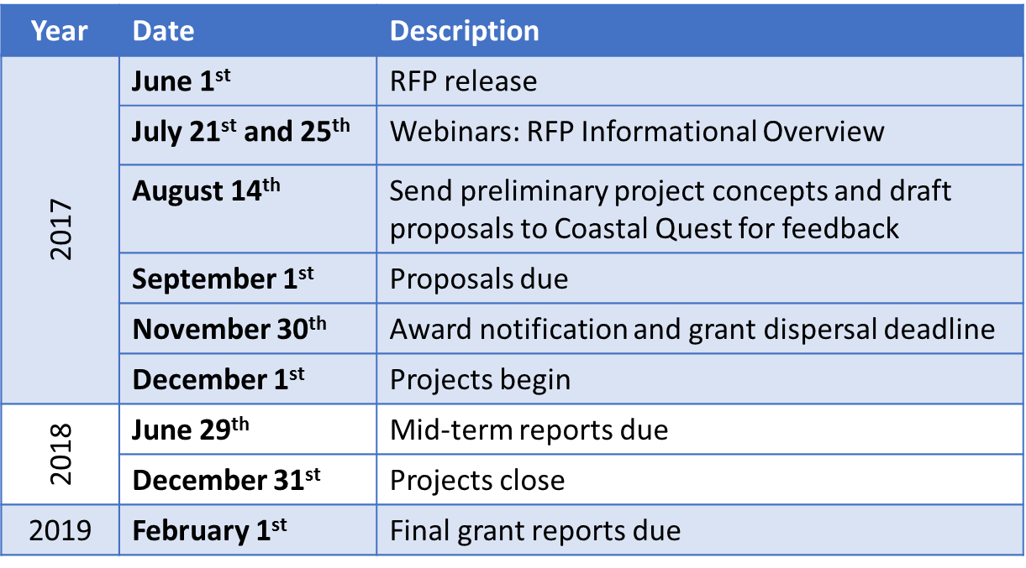
- Timeline: The timeline for the MPA Collaborative Network Small Grants Program is as follows:
- Webinar: Coastal Quest will hold two identical webinars this summer on Friday, July 21 from 10-11am PDT and Tuesday, July 25 from 5-6pm PDT. The webinars will provide an informational overview of the MPA Collaborative Network Small Grants Program Request for Proposal (RFP) (now available online). Representatives from OPC and the California Department of Fish and Wildlife will attend both webinars to field any questions Collaboratives may have.
- Workshop: Coastal Quest asked survey respondents to identify potential workshop topics for Collaboratives in the future. Top workshop topics identified included: identify where to look for funding; understand tribal needs; increase awareness on MPA laws and regulations; and develop effective measurements of impact. During the webinar, participants voted on priority workshop topics, with funding (and fundraising mechanisms) resulting as a top priority. This funding workshop will include an overview of specific financing mechanisms Collaboratives could utilize (e.g., public-private funding sources at the county scale, “outside-the-box” funding streams like Section 309 grants) and how to access more traditional grant funding (e.g., philanthropic donors). Collaboratives can also find useful information on MPA financing mechanisms in the Protecting our Marine National Treasures Report.
- Contact information: For more information on the MPA Collaborative Network Small Grants Program and RFP, please visit: www.coastal-quest.org/?page_id=1071
